Changing colour tutorial

This shows how to change the colour of dropped cubes.

1. Create a new scene

Start by creating a new scene called colours.

Add a 3D cube and name it drop.

Add another 3D cube directly underneath the drop cube and name it colour change trigger.

Give these boxes a collider and give the drop cube a Rigidbody (make sure the use gravity tickbox is checked).

1. Scripting

Create a new C# script called ColourChange.

This script will allow us to change the colour of cubes that touch a collider.

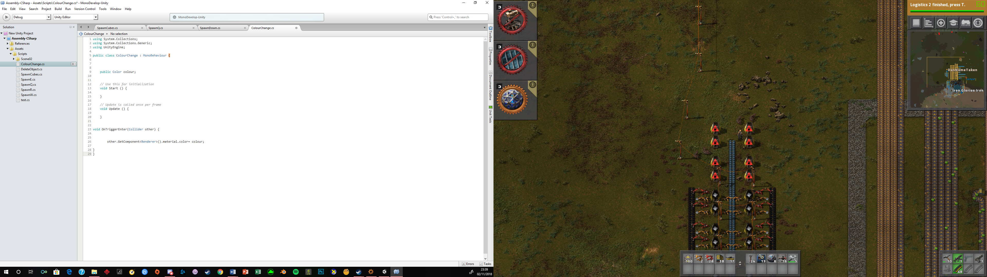

1. Attaching the script and components

Now after saving the script switch back to the Unity editor.

Attatch the ColourChange script to the colour change trigger cube.

After attaching the script you can select the colour you want the cube to change to.

Run the scene and the drop cube should change colour as it passes through the colour change trigger cube.